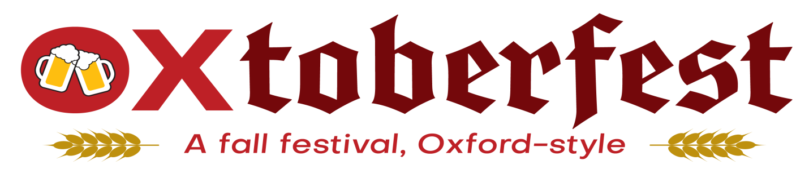

Sponsor/Vendor/Artisan Sign-Up Form

Participate in our 2nd Oxtoberfest on Saturday, October 14th, 2023
1:00pm-8:00pm in the Uptown Parks/High Street / Set-up available 11:00am-12:45pm

Company Name: ____________________________________________________________
Contact Name: ____________________________________________________________
Address: ____________________________________________________________
Email: ____________________________________________________________
Website: ____________________________ Phone: _________________________
Are you a Chamber Member? YES_______ NO _______

Please pick level of sponsorship below, send back to Kelli Riggs no later than Thursday, August 31st, 2023, to have your logo (according to level of sponsorship) on poster/signage and reserve your spot.
Again as noted in vendor pricing, ALL operations and sales must be fully self-contained!
NO tents, table, chairs, outside electric, water, gas, etc. will be available!

1 – Red Brick Sponsor $6,000.00 ___ 2 – Premier Sponsor $4,000.00 ___

2 – Music Sponsor $3,000.00 ___ 5 – Title Sponsor $2,000.00 ___

4 – Area Sponsorship $ 750.00 ___ Limited – Corporate
Retail/Craft Vendor $ 350.00 ___
3 – Food Vendor $ 200.00 ___
Limited – Independent
Retail/Craft Vendor $ 100.00 ___
Limited – Table Sponsor $ 100.00 ___

Please Invoice Check Included

If sponsorship includes banners on the main stage, banners must be delivered to the Oxford Chamber office by Tuesday, October 10th, 2023.
Payment in full is due by September 25th, 2023. Checks payable to:
Oxford Chamber of Commerce
102 W. High St., Oxford, OH 45056 / Visa or MasterCard accepted at the Chamber office or by phone.
For more information, call: (513) 523-5200

